**Assignment - 2**

Create a table person(id, name, address, post,salary)

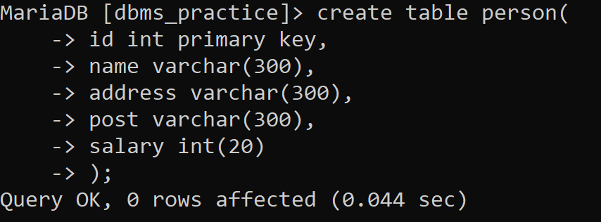

Now write SQL queries to make the changes in the given table:

* Rename table name into employee



* Rename column name



* Add column/s

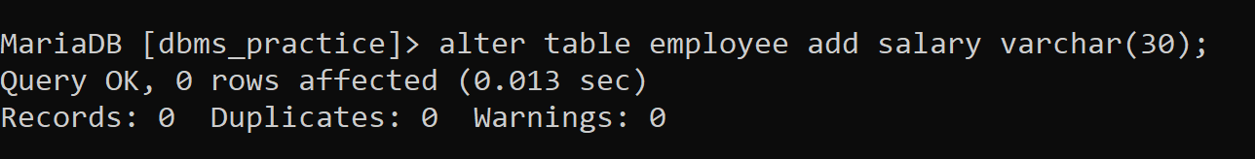

* Remove column/s



* Modify data type
* 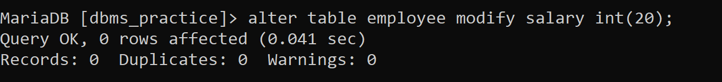
* Modify datatype length

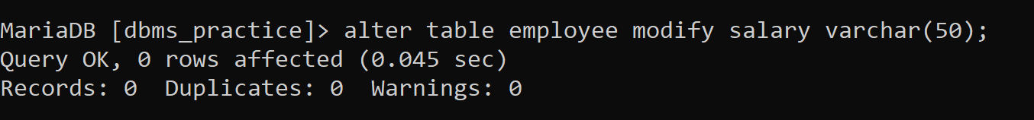

* Add constraints

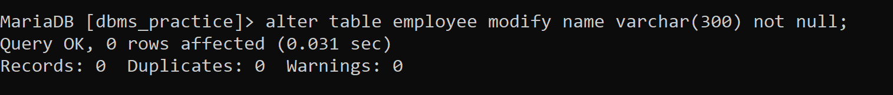

* Remove constraint

